Company Name: 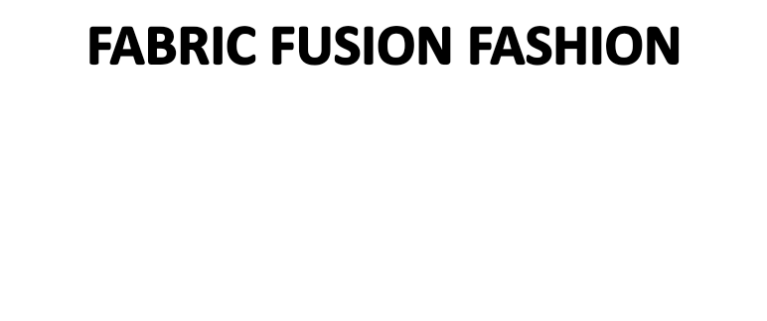

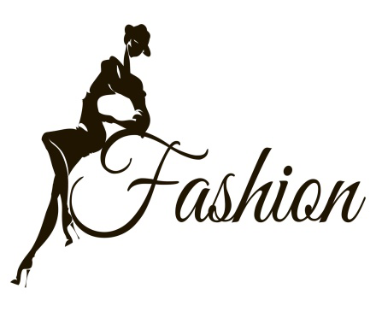

**Name: Shilpi Biswas**

**Batch: 48**

**Date: 09-12-2024**

**Industry:** Fashion Design and Apparel

**Business Model:** B2C (Business-to-Consumer)

**Management Team**

**Founder/CEO:** MD.Sumon

**Creative Director: Samira**

**Marketing Director: Joy**

**Sales Manager: Rabul**

**Operations Manager:** Rajib

**Customer Service Manager:** Tanvir

**Contents**

Mission Statement 3

Vision 3

Executive Summary: 3

Services: 4

5

Product Line 5

Seasonal Collections: 5

Signature Lines: 5

Custom Designs: 5

Target Market 5

Primary Market: 5

Secondary Market: 5

Competitive Advantage 6

Marketing Strategy 6

Sales Channels 6

Operations Plan 6

Financial Plan 6

Business Plan 7

Sales and Cost Statistics 8

Conclusion: 8

# Mission Statement

To create unique, high-quality fashion pieces that inspire confidence and express individuality. We aim to blend contemporary trends with timeless elegance, offering our customers unparalleled style and comfort.

# Vision

To become a leading fashion brand known for innovation, quality, and sustainability, setting new standards in the fashion industry.

# Executive Summary:

Fabric Fusion Fashion is a unique clothing brand that blends traditional and contemporary styles to create innovative fashion pieces. Our mission is to provide high-quality, trendy clothing for men and women while promoting sustainability and social responsibility. With our focus on fusion, we aim to cater to diverse tastes and preferences in the fashion industry. Fabric Fusion Fashion specializes in designing and manufacturing clothing that seamlessly merges different fabrics, textures, and styles. Our product line includes a wide range of apparel, including casual wear, formal attire, and accessories. By combining traditional craftsmanship with modern design techniques, we offer customers distinctive fashion choices that stand out in the market.

**Products:**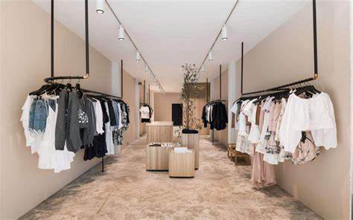

• **Clothing**:

* Tops: T-shirts, blouses, shirts, tunics, etc.
* Bottoms: Pants, jeans, skirts, shorts, etc.
* Dresses: Casual dresses, cocktail dresses, formal gowns, etc.
* Outerwear: Jackets, coats, blazers, etc.

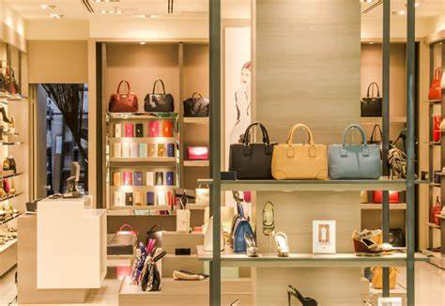

• **Accessories**:

* Scarves: Silk scarves, pashminas, shawls, etc.
* Handbags: Totes, clutches, crossbody bags, etc.
* Jewelry: Necklaces, earrings, bracelets, rings, etc.
* Belts: Leather belts, fabric belts, statement belts, etc.

• **Footwear**:

* Shoes: Flats, heels, boots, sandals, sneakers, etc.
* Socks: Fashion socks, athletic socks, etc.

• **Customized Fashion**:

* Made-to-measure clothing: Custom-fit shirts, pants, suits, etc.
* Tailoring services: Alterations, repairs, adjustments, etc.

# Services:

1. **Design Services**:
   * Custom design consultations: Offering personalized fashion advice and styling tips.
   * Bespoke design services: Creating one-of-a-kind clothing pieces tailored to individual preferences.
2. **Fashion Events**:
   * Fashion shows: Showcasing new collections and designs to potential customers and industry professionals.
   * Trunk shows: Hosting exclusive events where customers can preview and purchase upcoming collections.
3. **Sustainability Initiatives**:
   * Eco-friendly product lines: Introducing clothing and accessories made from sustainable materials, such as organic cotton, recycled fabrics, and vegan leather.
   * Recycling programs: Offering incentives for customers to recycle old clothing and accessories, promoting circular fashion practices.
4. **Community Engagement**:
   * Workshops and classes: Hosting educational events on topics such as fashion design, styling, and garment care.
   * Charity initiatives: Partnering with non-profit organizations to support social causes related to fashion, such as promoting ethical labor practices and empowering marginalized communities.

### 

# Product Line

## Seasonal Collections:

* **Spring/Summer Collection:** Light, airy fabrics and vibrant colors.
* **Fall/Winter Collection:** Warm, cozy materials and sophisticated hues.

## Signature Lines:

* **Evening Wear:** Elegant gowns and formal attire for special occasions.
* **Casual Chic:** Stylish yet comfortable everyday wear.
* **Workwear:** Professional and fashionable office attire.
* **Accessories:** Scarves, hats, belts, and jewelry to complement our clothing lines.

## Custom Designs:

* **Made-to-Measure Services:** Personalized fitting and design for unique, tailored garments.
* **Bridal and Special Events:** Custom bridal gowns and event-specific fashion pieces.

# Target Market

## Primary Market:

* **Fashion-Conscious Consumers:** Individuals who value unique and high-quality fashion.
* **Professionals:** Individuals seeking stylish and sophisticated workwear.

## Secondary Market:

* **Event Attendees:** Individuals looking for exclusive evening wear and special occasion outfits.
* **Fashion Enthusiasts:** People interested in custom designs and exclusive collections.

## Competitive Advantage

1. **Unique Designs:** Offering exclusive, innovative designs not found in mass-market stores.
2. **Quality Craftsmanship:** Emphasizing superior materials and meticulous construction.
3. **Sustainable Practices:** Using eco-friendly materials and ethical manufacturing processes.
4. **Customization Options:** Providing made-to-measure services for a perfect fit.
5. **Inclusive Sizing:** Designing for a diverse range of body types.

## Marketing Strategy

1. **Digital Marketing:** Utilizing social media, SEO, and online advertising to reach fashion-forward audiences.
2. **Influencer Collaborations:** Partnering with fashion influencers to promote our brand.
3. **Fashion Shows:** Showcasing collections at fashion weeks and exclusive events.
4. **Content Marketing:** Creating engaging content such as blogs, lookbooks, and style guides.

## Sales Channels

1. **E-Commerce Website:** A visually appealing online store for direct-to-consumer sales.
2. **Flagship Store:** An upscale retail location to offer an immersive brand experience.
3. **Pop-Up Shops:** Temporary stores in high-traffic locations to create buzz and drive sales.

## Operations Plan

1. **Design Team:** A talented team of designers to create unique fashion pieces.
2. **Supplier Partnerships:** Sourcing high-quality, sustainable materials from reliable suppliers.
3. **Manufacturing:** Combining in-house production with trusted third-party manufacturers.
4. **Quality Control:** Implementing rigorous quality control measures to ensure product excellence.
5. **Logistics:** Efficiently managing inventory, shipping, and delivery to ensure timely fulfillment.

## Financial Plan

1. **Startup Costs:** Estimating initial expenses including design, production, marketing, and retail setup.
2. **Revenue Streams:** Projecting income from direct sales, custom orders, and boutique partnerships.
3. **Pricing Strategy:** Setting competitive prices to attract customers while ensuring profitability.
4. **Funding:** Exploring options such as personal savings, business loans, or investors for initial funding.

# Business Plan





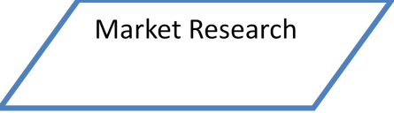









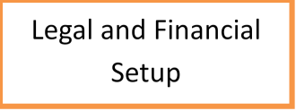







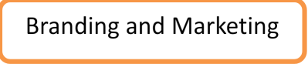







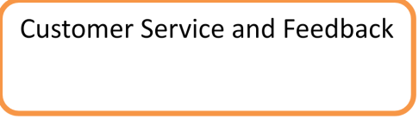





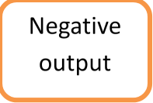





**Sales and Cost Statistics:**



# Conclusion:

TrendLine Couture aims to redefine fashion by offering unique, high-quality designs that celebrate individuality and sustainability. With a clear vision, strong values, and a comprehensive business plan, TrendLine Couture is positioned to make a significant impact in the fashion industry.